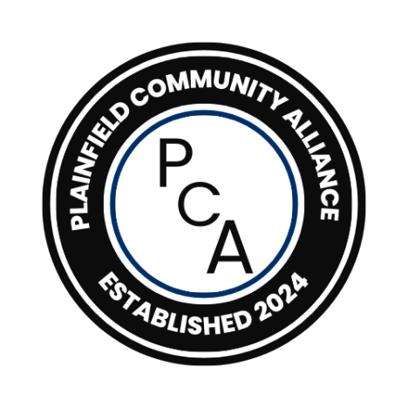

**BULLYING:**

**Home, School, Online**

**Plainfield Community Alliance**

***Special Topic Presentation***

Presented by Joan Caton, PhD, Nuhie Faheem,

& a representative from Plainfield School District 202

**WHAT:** A 2-hour presentation/audience participation on what bullying is, types of bullying, causes, what can be done to prevent it, and what is being done in our schools when it happens. A handout of information covered, plus important resources for additional support, will be distributed at the end of the event.

**WHEN: NEW DATE**, **April** **27th**, 11 a.m. to 1 p.m.

**WHERE:** Plainfield Congregational Church UCC, 24020 W. Fraser RD; at the corner of Rt. 59 and Fraser Rd (Turn onto Fraser & park in the back).

**WHY:** To discuss serious topics that people from all backgrounds can relate to and/or have been affected by; to learn about each other through problem-solving such topics together.

**Plainfield Community Alliance is a non-denominational, non-political organization with a goal of fostering unity, collaboration, and community empowerment to address local challenges, celebrate diversity, and promote a sense of belonging for everyone.**

***For more information about the Special Topic Presentation/workshop,***

***please contact Joan at 815-954-5335.***